Patient |  | Date
Notes

Important Instructions, please read: When transferring a setup from the Universal Couchtop™ or ONEPlatform™ to the Body Pro-Lok ONE Rails-Only System, the ONEBridge™ must be adjusted and set 50 mm lower than on the Universal Couchtop or ONEPlatform.
Rails-Only device indexed  to table at | and

type of Respiratory Plate | Choose an item.  (If none, skip this section)
ComfortCare™ Cushion Used? | Choose an item.
ONEBridge (Side A) |  | 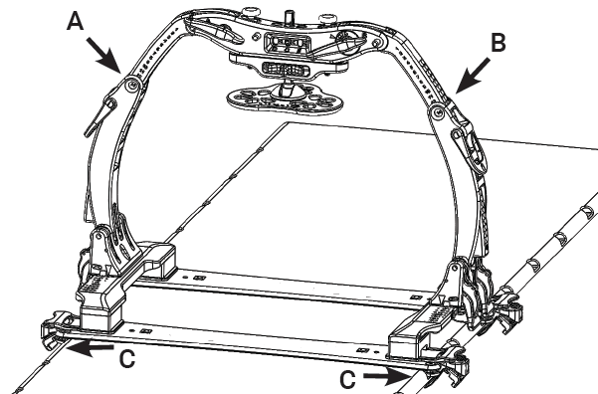
ONEBridge (Side B)
Docking Index (c)
onebRIDGE lATERAL pOSITION (D) |  | 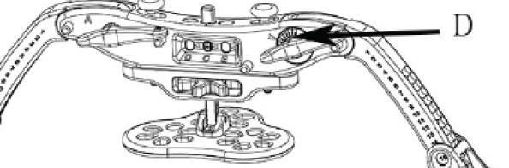
rESPIRATORY pLATE hEIGHT (E) |  | 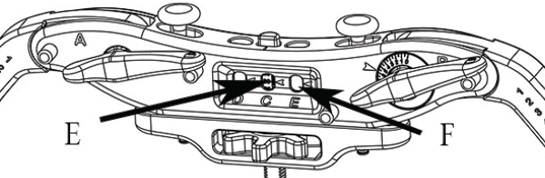
rESPIRATORY pLATE  lATERAL pOSITION (F) | Choose an item.
iF USING COMFORTCARE CUSHION,  SET PRESSURE BETWEEN (G) | and | 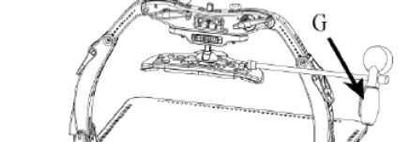

rESPIRATORY BELT uSED? | Choose an item.  (If no, skip this section) | 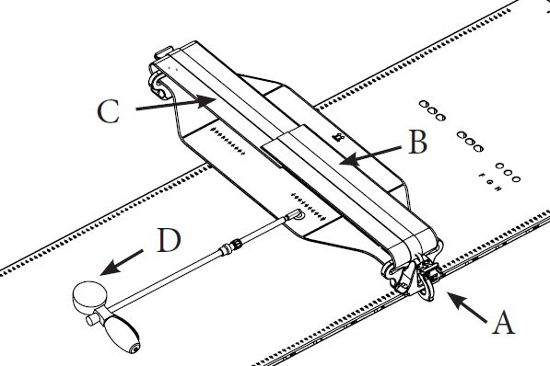
Docking index (A)
Left Velcro Strap indexing (B)
Right Velcro Strap indexing (c)
Set Pressure between (D) | and

Clam-Lok™ cushion uSED? | Choose an item.  (If no, skip this section) | 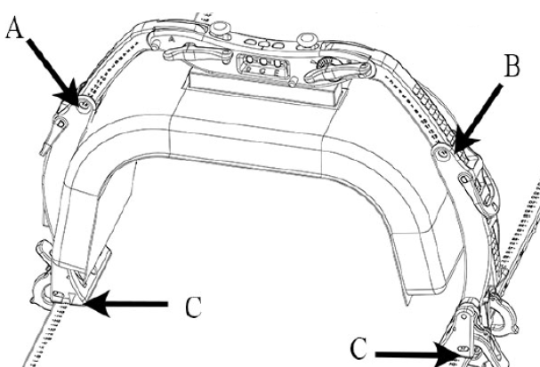
oNEBridge (side A)
onebridge (side B)
Docking index (c)
onebridge lateral position (D) |  | 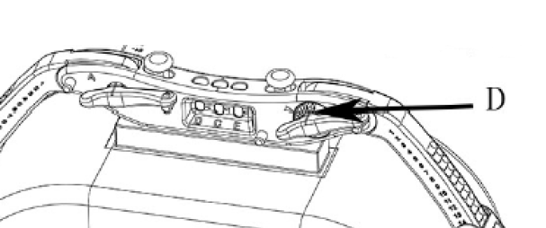

Additional Indexable Accessory
Indexed at

Additional Indexable Accessory
Indexed at

Additional Indexable Accessory
Indexed at

