Patient |  | Date of Birth
Notes

Overlay and extension indexing | Choose an item. | 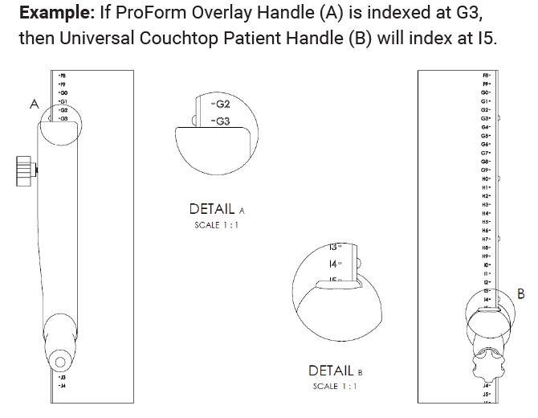  Example: If ProForm Overlay Handle (A) is indexed at G3, then Universal Couchtop Patient Handle (B) will index at I5.

