Patient |  | Date
Notes

Note: The Feetfix™ Couch Support can be utilized without the Combifix.
Lok-Bars™ indexed to table at
(ex: h1, f2)

Feetfix style couch support position indexed to Combifix at | Choose an item. | 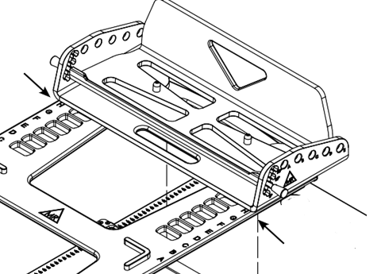
Feetfix style couch support rotation | Choose an item. | 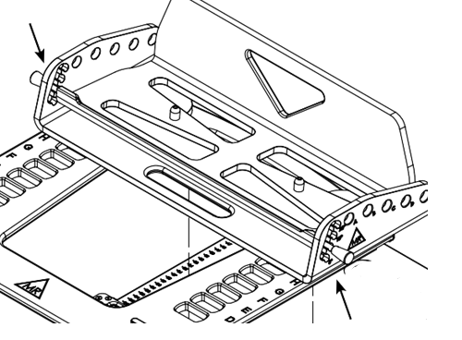
Feetfix Cushion Style | Choose an item. | 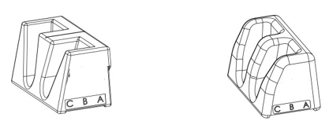
Feetfix Bracket Style | Choose an item. | 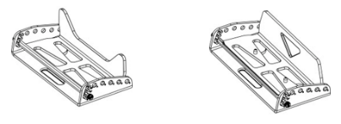

Kneefix™ Style | Choose an item. | 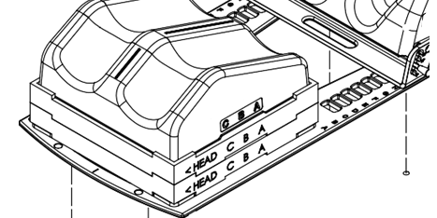
number of Kneefix Elevation Blocks | Choose an item.

Type of shoulder retractor | Choose an item. | 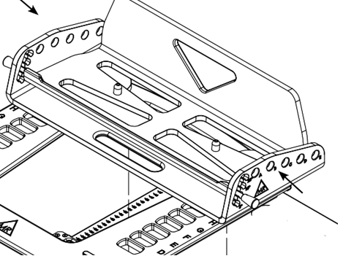
Shoulder Retractor setting | Choose an item.

