Patient |  | Date of Birth
system serial #
Notes

headrest type | Choose an item.
type of customizable head cushion (if applicable)
head support used | Choose an item. | 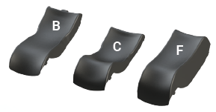

Thermoplastic type | Choose an item. | 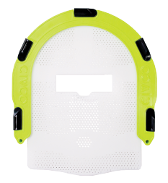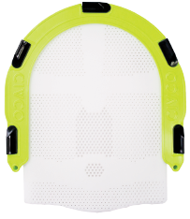
Shoulder thermoplastic Used? | Choose an item.

