Patient |  | Date of Birth
Notes

Reference Images:
Orientation: Longitudinal | Orientation: Transverse
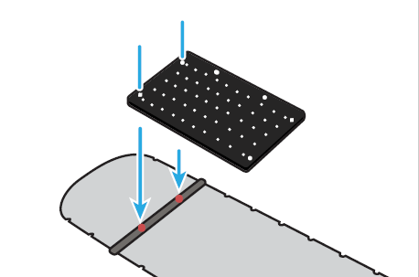 | 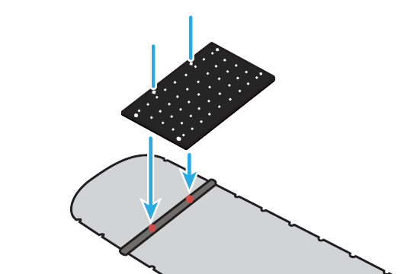
Indexing extremity riser to multiFix 2 | Using indexing posts
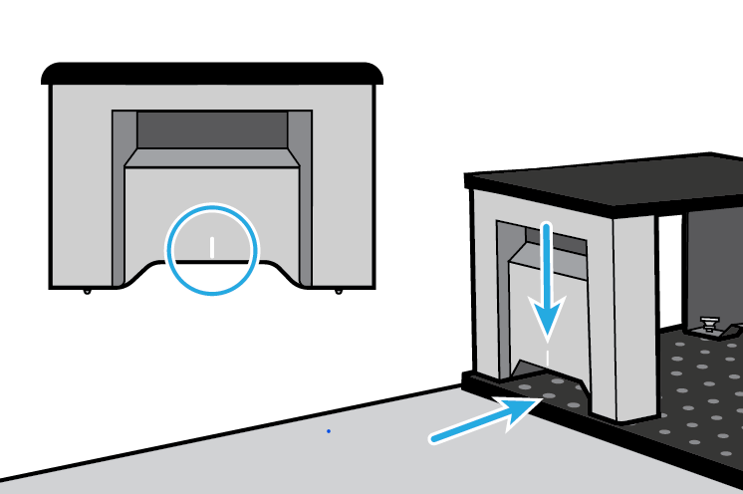 | 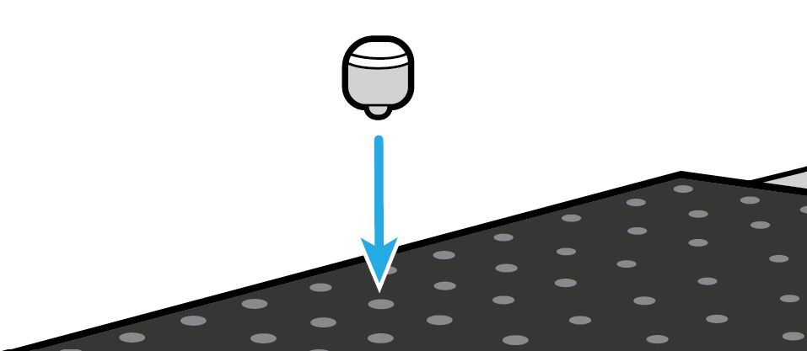

Orientation selection
Orientation Selection: Extremity Riser  Direction of corner arrows relative to gantry at Sim |  | ☐ Longitudinal | ☐ |  | ☐
 |  | ☐ Transverse | ☐ |  | ☐
Treatment plan rotated from simulation? |  | ☐ Yes: ____ᵒ ☐ No ☐ Unknown at Sim
Lok-Bar(s) indexed to COUCHTOP at
Lok-Bar 1 |  | Transverse Lok-Bar used? |  | ☐ Yes ☐ No
Lok-Bar 2 OPTIONAL | ​​☐​ Slide Guide ☐​ N/A | Transverse Lok-Bar setting:

configuration | ☐ Riser *  ☐ Direct to couchtop | 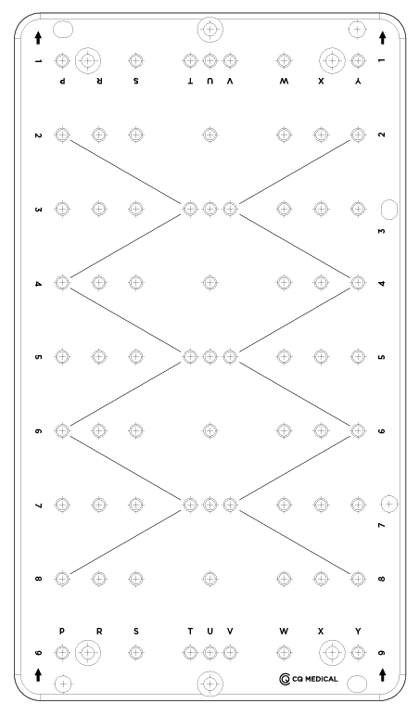  
Indexing Posts /  custom cushion Used? | ☐ Yes ☐ No
INDEXING POST 1 indexed at
INDEXING POST 2 indexed at
INDEXING POST 3 indexed at
Indexing Posts are interchangeable
tHERMOPLASTIC uSED? | ☐ Yes ☐ No
fRAME 1
fRAME 2
fRAME 3

*If using in Riser configuration, see Setup Sheet for MultiFix® 2

Optional additional accessories:
☐ Cushions / devices for support / comfort / clinical setup, e.g. pillows
☐ Vacuum Bag
☐ Accuform™ / custom cushion without Indexing Posts

Additional accessory |  | Indexed To PLATFORM AT
Additional accessory |  | Indexed To PLATFORM AT
Additional accessory |  | Indexed To PLATFORM AT

Orientation selection
Orientation Selection: Extremity Riser  Direction of corner arrows relative to gantry at Sim |  | ☐ Longitudinal | ☐ |  | ☐
 |  | ☒ Transverse | ☐ |  | ☒
Treatment plan rotated from simulation? |  | ☒ Yes: 90ᵒ ☐ No ☐ Unknown at Sim
Lok-Bar(s) indexed to COUCHTOP at
Lok-Bar 1 | H3 | Transverse Lok-Bar used? |  | ☒ Yes ☐ No
Lok-Bar 2 OPTIONAL | ☐ Slide Guide ☒ N/A | Transverse Lok-Bar setting: |  | 10cm

configuration | ☐ Riser *  ☒ Direct to couchtop | 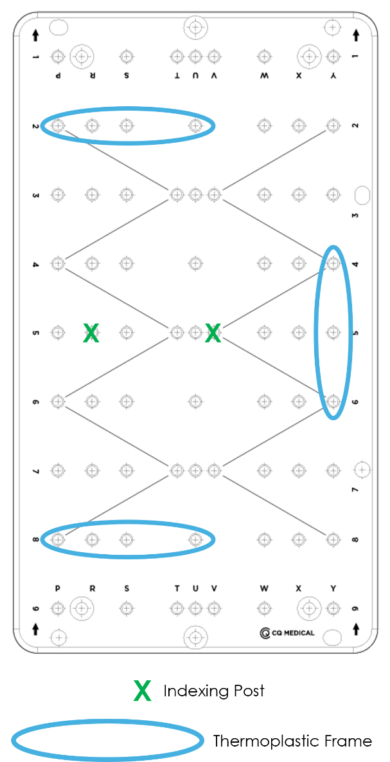
Indexing Posts /  custom cushion Used? | ☒ Yes ☐ No
INDEXING POST 1 indexed at | R5
INDEXING POST 2 indexed at | V5
INDEXING POST 3 indexed at  Indexing Posts are interchangeable | N/A
tHERMOPLASTIC uSED? | ☐ Yes ☐ No
fRAME 1 | P2 / U2
fRAME 2 | P8 / U8
fRAME 3 | Y4 / Y6

*If using in Riser configuration, see Setup Sheet for MultiFix® 2

