Patient |  | Date of Birth
Notes

Device SELECTION
Select any/all devices that apply:
☐ MultiFix 2
☐ Extremity Riser (with legs)
☐ Extremity Riser Plate (without riser legs; Riser Plate indexed directly to couchtop)
☐ Other configuration:

Select any/all positioning accessories that apply:
☐ Indexing Pegs
☐ Accuform™ / custom cushion
☐ Thermoplastic(s)

Orientation: Longitudinal | Orientation: Transverse
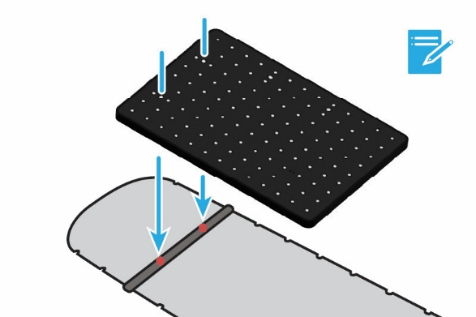 | 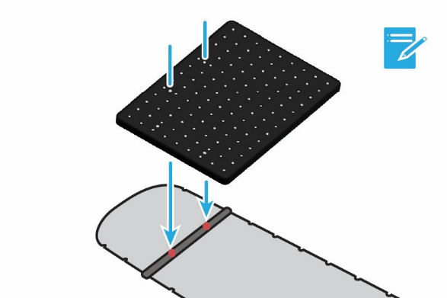

Orientation selection
For devices indexed directly to couchtop
Orientation Selection: MultiFix 2  Select direction of corner arrows relative to gantry | ☐ Longitudinal | ☐ | ☐
 | ☐ Transverse | ☐ | ☐
Orientation Selection: Extremity Riser Plate  Select direction of corner arrows relative to gantry | ☐ Longitudinal | ☐ | ☐
 | ☐ Transverse | ☐ | ☐

Lok-Bar(s) indexed to COUCHTOP at
multiFix 2 |  | Extremity Riser Plate
Lok-Bar™ 1 |  | Lok-Bar 1
Lok-Bar 2 |  | Lok-Bar 2  OPTIONAL | ☐ Slide Guide  ☐ N/A

INDEXING TO MULTIFIX 2:
Extremity Riser Used? | ☐ Yes  ☐ No | If ‘No’, skip to pg. 4  If using Extremity Riser Plate indexed directly to couchtop, skip to pg. 7
1) Riser LEG 1 indexed at |  | Indicate index locations:  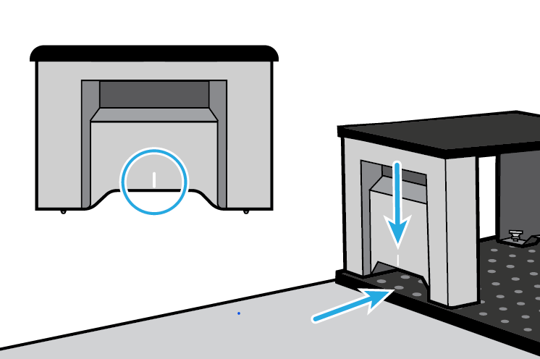
2) Riser LEG 2 indexed at

Note: Riser legs are interchangeable

Indexing Pegs Used? | ☐ Yes  ☐ No
1) Peg 1 indexed at |  | Indicate index locations:  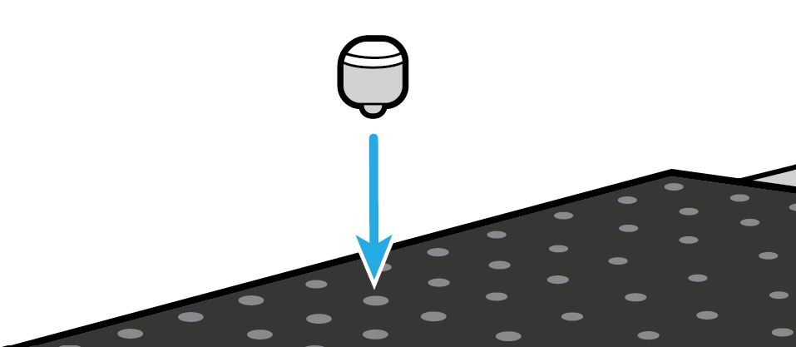
2) peg 2 indexed at

Note: Indexing pegs are interchangeable
Skip to pg. 7 if using Extremity Riser Plate indexed directly to couchtop.

tHERMOPLASTIC 1 | ☐ Yes  ☐ No
1) Frame 1 indexed at |  | Indicate index locations:
2) Frame 2 indexed at
3) Frame 3 indexed at
Optional
4) Frame 4 indexed at
Optional
5) Frame 5 indexed at
Optional
Skip to pg. 7 if using Extremity Riser Plate indexed directly to couchtop.

tHERMOPLASTIC 2 | ☐ Yes  ☐ No
1) Frame 1 indexed at |  | Indicate index locations:
2) Frame 2 indexed at
3) Frame 3 indexed at
Optional
4) Frame 4 indexed at
Optional
5) Frame 5 indexed at
Optional
Skip to pg. 7 if using Extremity Riser Plate indexed directly to couchtop.

INDEXING TO EXTREMITY RISER PLATE:
Indexing Pegs Used? | ☐ Yes  ☐ No
1) Peg 1 indexed at |  | Indicate index locations:  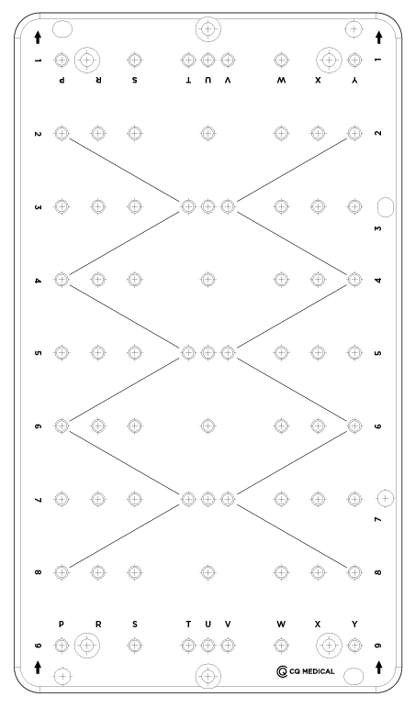
2) peg 2 indexed at

Note: Indexing pegs are interchangeable
If using MultiFix 2 without Extremity Riser, return to previous section.

tHERMOPLASTIC 1 | ☐ Yes  ☐ No
1) Frame 1 indexed at |  | Indicate index locations:
2) Frame 2 indexed at
3) Frame 3 indexed at
Optional
If using MultiFix 2 without Extremity Riser, return to previous section.

tHERMOPLASTIC 2 | ☐ Yes  ☐ No
1) Frame 1 indexed at |  | Indicate index locations:
2) Frame 2 indexed at
3) Frame 3 indexed at
Optional
If using MultiFix 2 without Extremity Riser, return to previous section.

Recommended additional accessories:
☐ Cushions / devices for support / comfort / clinical setup, e.g. pillows
☐ Vacuum Bag

Additional accessory |  | Indexed To PLATFORM AT
Additional accessory |  | Indexed To PLATFORM AT
Additional accessory |  | Indexed To PLATFORM AT
Additional accessory |  | Indexed To PLATFORM AT

