Patient |  | Date of Birth
Notes

treatment site | Choose an item.

SIMULATION & PATIENT SETUP ORIENTATION
Locating Bar Indexed to Couch at
Device Orientation Selection | ☐ Lateral / Transverse  ☐ Longitudinal

TREATMENT ORIENTATION
Locating Bar Indexed to Couch at
Device Orientation Selection | ☐ Lateral / Transverse  ☐ Longitudinal
NOTE: In some workflows, simulation and treatment may not occur in the same orientation. Ensure patient setup and treatment orientations as well as planning procedures align with clinician recommendations.

Lateral / TRANSVERSE ORIENTATION | LONGITUDINAL ORIENTATION
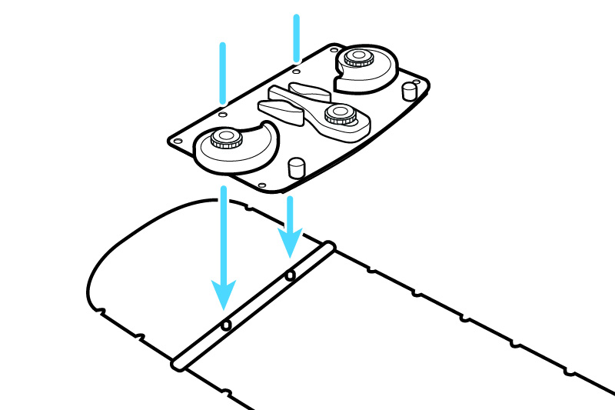 | 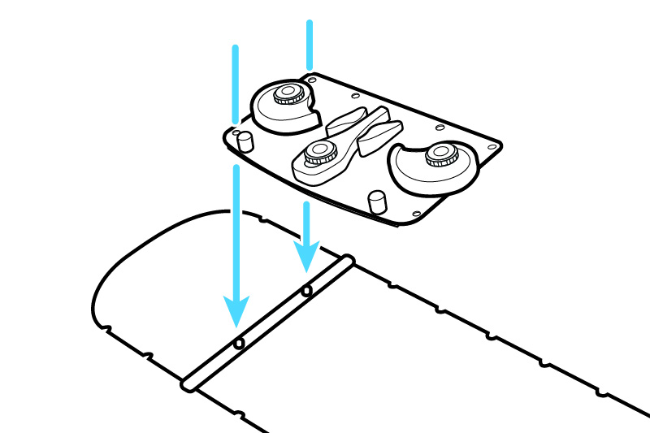

Right Hand Indexing
1) Thumb Lock indexed at |  | 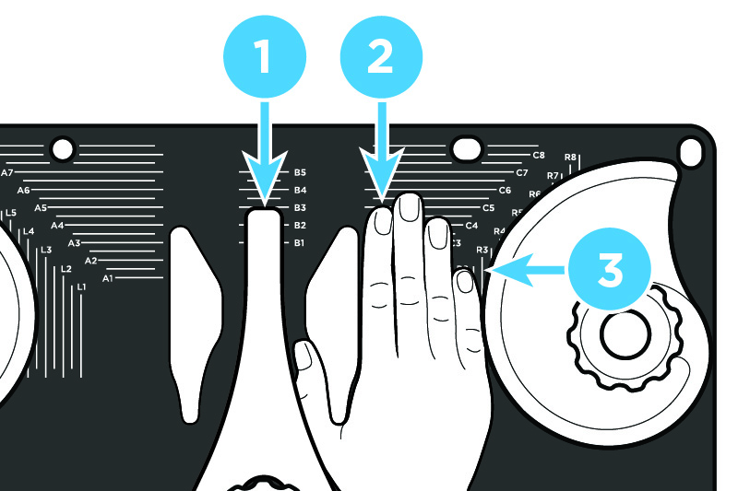
2) index finger INDEXED AT
3) finger lock INDEXED AT

Left Hand Indexing
1) Thumb Lock indexed at |  | 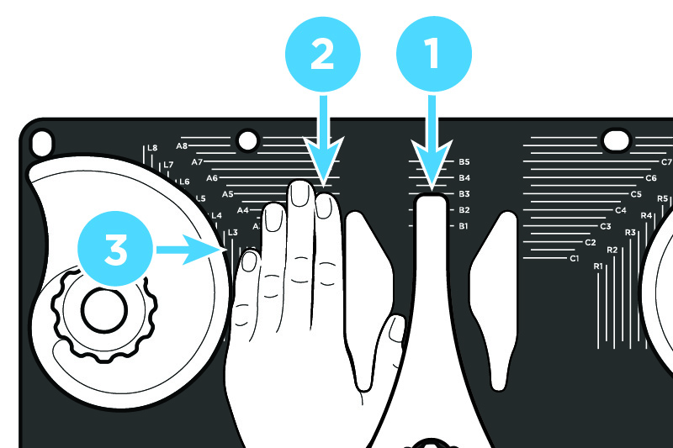
2) index finger INDEXED AT
3) finger lock INDEXED AT

Recommended additional accessories:
☐ Bolus
☐ Custom cushion(s)
☐ Prone positioning cushions
☐ Vacuum Bag

Additional accessory |  | Optional: Indexed AT
Additional accessory |  | Optional: Indexed AT
Additional accessory |  | Optional: Indexed AT
Additional accessory |  | Optional: Indexed AT
Additional accessory |  | Optional: Indexed AT

