Patient |  | Date of Birth
Notes

Lok-Bar™ indexed to table at |  | 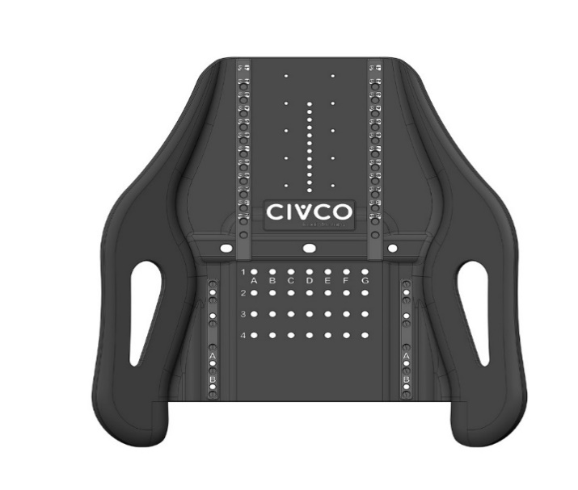  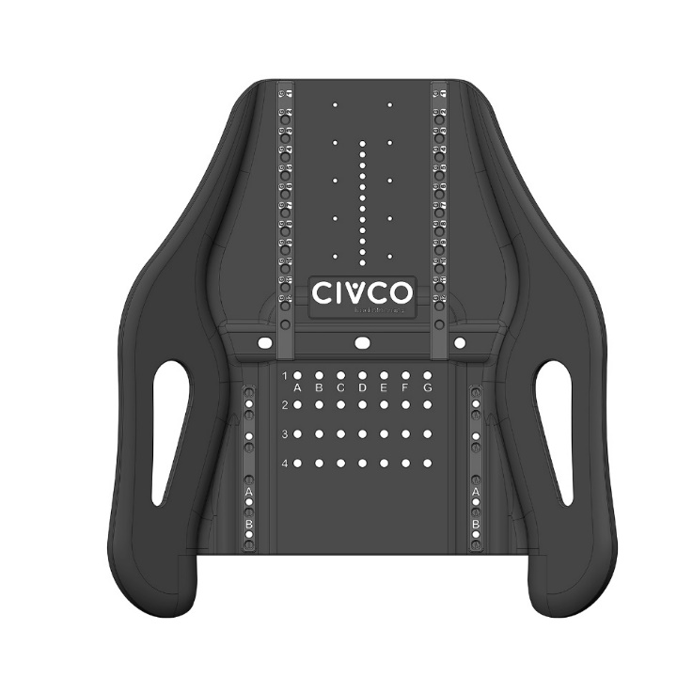
headrest type |  | headrest indexed at
handle type |  | left handle indexed at
 |  | Right handle indexed at
chin thermoplastic used? | Choose an item. | chin thermoplastic indexed at | Choose an item.
VAC-LOK™ USED? | Choose an item.

