Patient |  | Date of Birth
Notes

head support used
index lok-Bar™ to table (ex: h1, f2)
set tilting board elevation angle | Choose an item. | 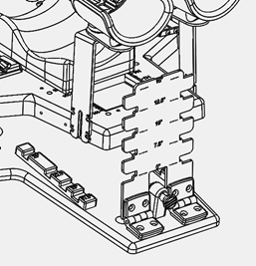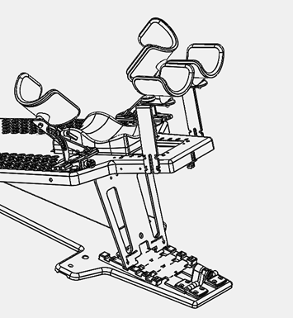
bottom stop position | Choose an item. | 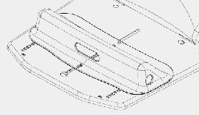
head Support Position | Choose an item. | 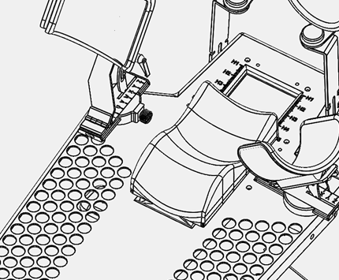
right UPPER ARM SUPPORT ROTATION | Choose an item. | 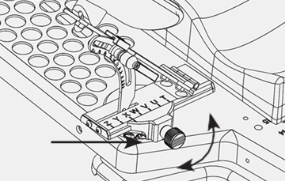
left UPPER ARM SUPPORT ROTATION | Choose an item.
right upper arm support horizontal position | Choose an item. | 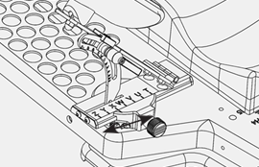
left upper arm support horizontal position | Choose an item.
right upper arm support angle | Choose an item. | 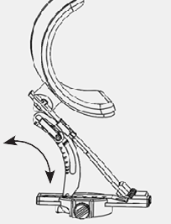
left upper arm support angle | Choose an item.
right lower arm support height | Choose an item. | 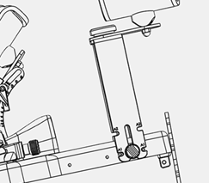
left lower arm support height | Choose an item.
laser alignment location |  | 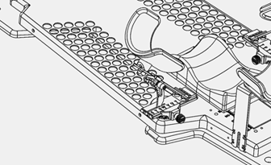
theromplastics used | ☐ Head-Only ☐ Breast

