Patient |  | Date of Birth
Notes

index Lok-Bar™ to table (ex h1, f2)
If using monarch with lok-bar only, skip to “hand grip used”
tilting board elevation angle | Choose an item. | 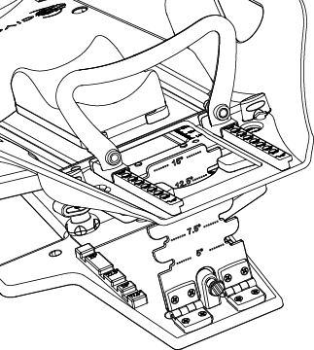  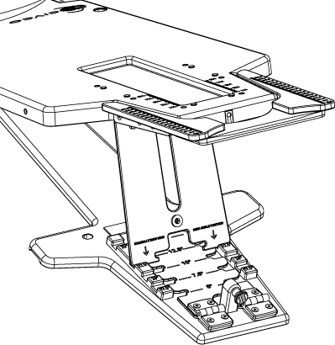
bottom stop position | Choose an item. | 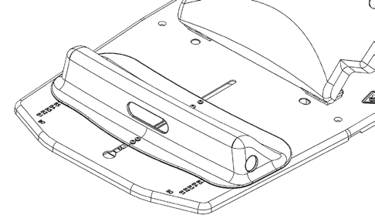
MONARCH OVERHEAD ARM POSITIONER | Choose an item. | 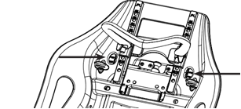
HAND GRIP USED  (CHECK ONE) | Choose an item.
 | One Piece Placement Details  Choose an item.  HAND POSITION  ☐ Top ☐ Side | Individual Grips Details  Left: Choose an item.  Right: Choose an item.
LASER ALIGNMENT LOCATION
THERMOPLASTICS USED | ☐ Head-Only ☐ Breast

