Patient |  | Date of Birth
Notes

inferior lok-bar indexed to table at (EX: H1, F2)
NUMBER OF RISER PAIRS USED | Choose an item.
TREATMENT OPENING LOCATION | Choose an item.
TREATMENT OPENING SIZE | Choose an item.

CONTRALATERAL BREAST CUSHION | Choose an item.
 | 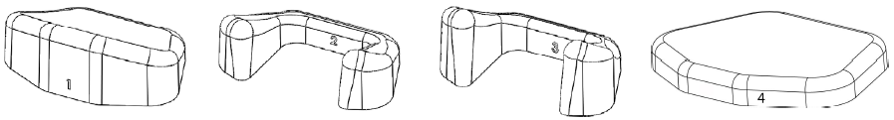

HEAD CUSHION SUPERIOR SETTING | Choose an item. | 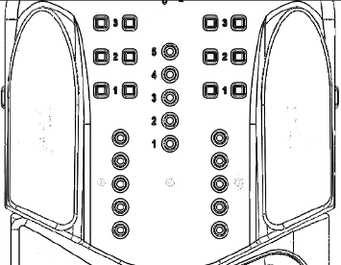
HEAD CUSHION height SETTING | Choose an item. | 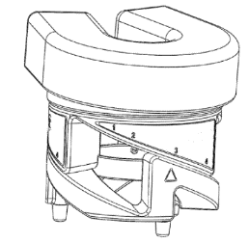

left handle position | Choose an item. Choose an item. Choose an item.
right handle position | Choose an item. Choose an item. Choose an item.

bridge type | Choose an item.
bridge location | Choose an item. | 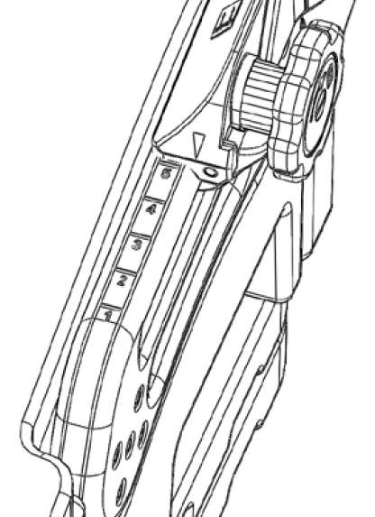
bridge height | Choose an item. | 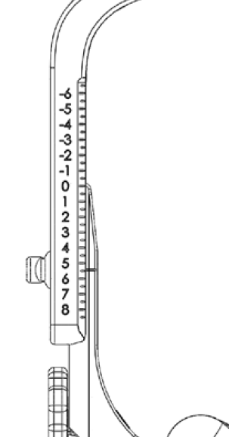
accessory used | Choose an item.

side scale reading (0–220mm) |  | 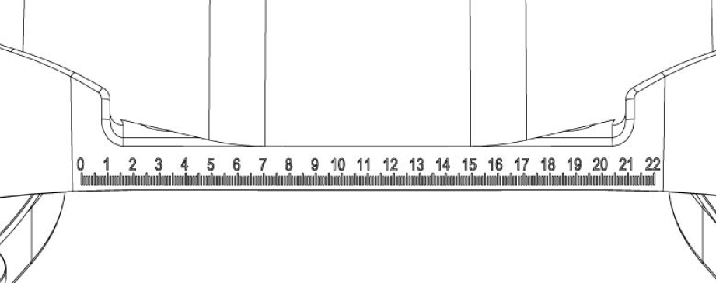
front scale reading (0–300mm) |  | 

