Patient |  | Date
Notes

Lok-Bar™ indexed
to couchtop at
(ex: h1, f2)
Handle Type | Choose an item.
Handle Location | Choose an item. | Choose an item. | 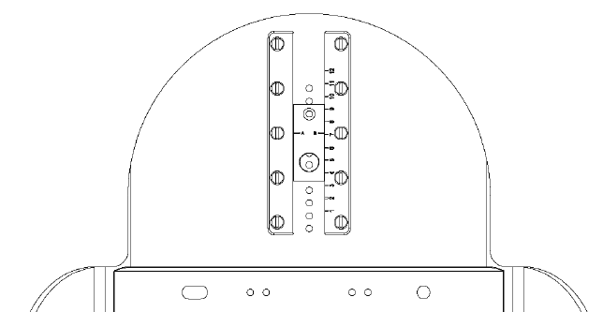
T-GRIP Handle Height | Choose an item. |  |  | 