Patient |  | Date of Birth
Notes

Thorawedge Locator Used: | Choose an item. If no, skip to Order of Wedges
Lok-Bar™ Indexed at: |  |  | 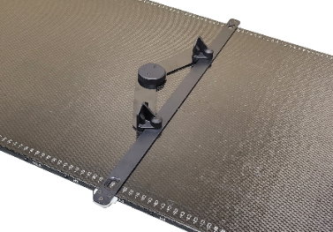
Order of wedges  (top to bottom)  5- or 10-degree wedges |  | ° | 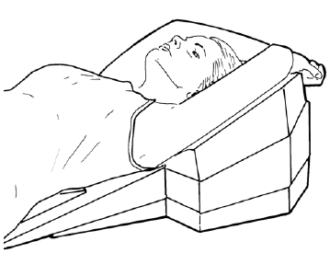
 |  | °
 |  | °
 |  | °
 |  | °
 |  | °
 |  | °
Lumbar Support Orientation | ☐ 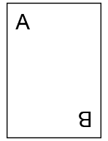 |  | ☐
Position Lumbar Support | Choose an item. |  | 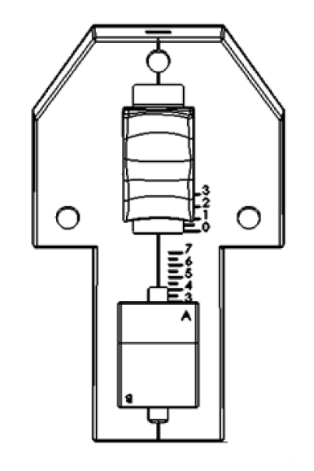
Position Head Support | Choose an item.

