Patient |  | Date of Birth
Notes

Locating Bars for indexing THE ALTA DEVICE are indexed to table at
ARMSHUTTLE ELITE Used? | Choose an item. | Armshuttle Hand Grips Indexed at
ARMSHUTTLE ELITE Used? | Choose an item. | Armshuttle headrest  indexed at
Vac-Lok Used? | Choose an item. | Vac-Lok Lok-Bar Indexed at
Elekta Reference frame used? | Choose an item. | Elekta Reference Frame Position | Choose an item.

Respiratory Plate Used | Choose an item. If none, skip to respiratory belt section
1) ONEBridge Side A |  | 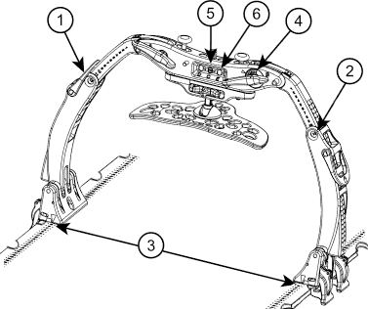
2) ONEBridge Side B
3) Docking Index
4) ONEBridge Lateral Position
5) Respiratory Plate Height
6) Respiratory Plate
Lateral Position
If using ComfortCare Cushion  with Wide Respiratory Plate)  7) Set pressure between | & | 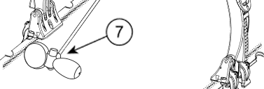

Respiratory Belt Used? | Choose an item. | ZiFix Traverse  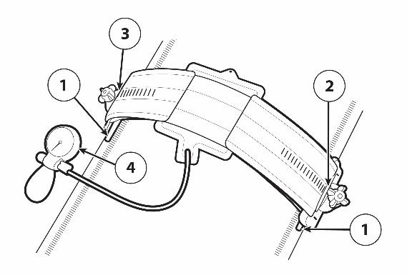  Body Pro-Lok ONE Respiratory Belt  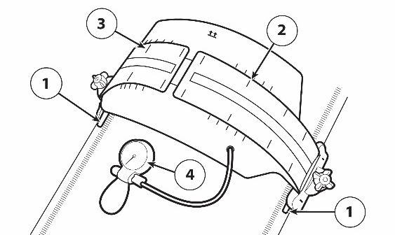
1) LEFT Docking Index
1) Right docking index
2) Left velcro indexed at
3) Right velcro indexed at
4) Set pressure between | &

Bridge with Clam-Lok  Cushion Used? | Choose an item. | 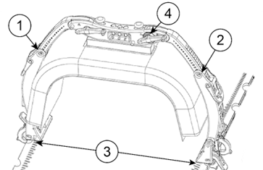
1) ONEBridge Side A
2) ONEBridge Side B
3) Docking Index
4) ONEBridge Lateral Position

KneeFix Used? | Choose an item. | Indexed to Alta Device at
KneeFix Used? | Choose an item. | location of kneefix on loK-bar | Choose an item.
Feetfix Used? | Choose an item. | Indexed to Alta Device at
Feetfix Used? | Choose an item. | location of feetfix on loK-bar | Choose an item.

flexlock knee support used? | Choose an item. | Indexed to Alta Device at
flexlock knee support used? | Choose an item. | location of knee support on loK-bar | Choose an item.
flexlock knee support used? | Choose an item. | Leg Strap Used? | Choose an item.
Flexlock feet support used? | Choose an item. | Indexed to Alta Device at
Flexlock feet support used? | Choose an item. | location of feet support on loK-bar | Choose an item.
Flexlock feet support used? | Choose an item. | Angle of Feet Support | Choose an item.
Flexlock feet support used? | Choose an item. | Foot Strap used? | Choose an item.

Additional indexable accessory |  | Indexed to Alta Device at
Additional indexable accessory |  | Indexed to Alta Device at

Patient hAND GRIPS USED? | Choose an item.
rIGHT HAND GRIP INDEXED AT |  | lEFT HAND GRIP INDEXED AT

